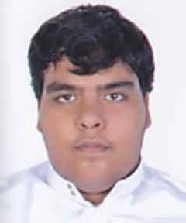**CURRICULUM VITAE**

**OBJECTIVE :**

Seeking to handle increasing responsibility and challenging assignments to harness my technical skills, knowledge and achieve recognition. I want to be part of an environment that promotes team effort and provide opportunity for value based growth as well as career advancement while making a significant contribution to employer organization.

**PERSONAL DETAILS:**

**NAME : SULTAN LAFI KHALIFA HUWAISH**

**NATIONALITY** : Bahrain

**C.P.R** : 000604925

**PASSPORT NO.** : 2157055

**DATE OF BIRTH** : 10/06/2000

**GENDER** : Male

**ADDRESS** : Flat:3,Bldg:352, Road:1706, Block : Bukowarah

**TELEPHONE** : +973 35020426

**MARITAL STATUS** : Single

**EDUCATIONAL QUALIFICATION**

* Bahrain Institute - Business
* Higher Secondary School

**LANGUAGES**

* Arabic / English

**SKILLS**

* Micro Soft Office

**DECLARATION**

I do hereby declare that above furnished information is true and correct to the best of my knowledge and belief.